Libya

## Political Stability Estimate Data

The data set shows the political stability estimate of the country each year.

## # A tibble: 19 x 5  
## country iso3c date stability stabilityCategory4   
## <chr> <chr> <dbl> <dbl> <chr>   
## 1 Libya LBY 1996 -0.987 moderately unstable  
## 2 Libya LBY 1998 -0.808 moderately unstable  
## 3 Libya LBY 2000 -0.297 moderately unstable  
## 4 Libya LBY 2002 -0.0975 moderately unstable  
## 5 Libya LBY 2003 0.120 moderately stable   
## 6 Libya LBY 2004 0.355 moderately stable   
## 7 Libya LBY 2005 0.449 moderately stable   
## 8 Libya LBY 2006 0.358 moderately stable   
## 9 Libya LBY 2007 0.747 moderately stable   
## 10 Libya LBY 2008 0.808 moderately stable   
## 11 Libya LBY 2009 0.833 moderately stable   
## 12 Libya LBY 2010 0.0281 moderately stable   
## 13 Libya LBY 2011 -1.29 highly unstable   
## 14 Libya LBY 2012 -1.59 highly unstable   
## 15 Libya LBY 2013 -1.84 highly unstable   
## 16 Libya LBY 2014 -2.35 highly unstable   
## 17 Libya LBY 2015 -2.20 highly unstable   
## 18 Libya LBY 2016 -2.28 highly unstable   
## 19 Libya LBY 2017 -2.33 highly unstable

## Political Stability Estimate Plot

The plot shows the trends of stabilization and destabilization for the each country.

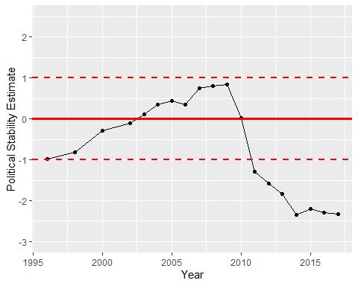

Political Stability Trend